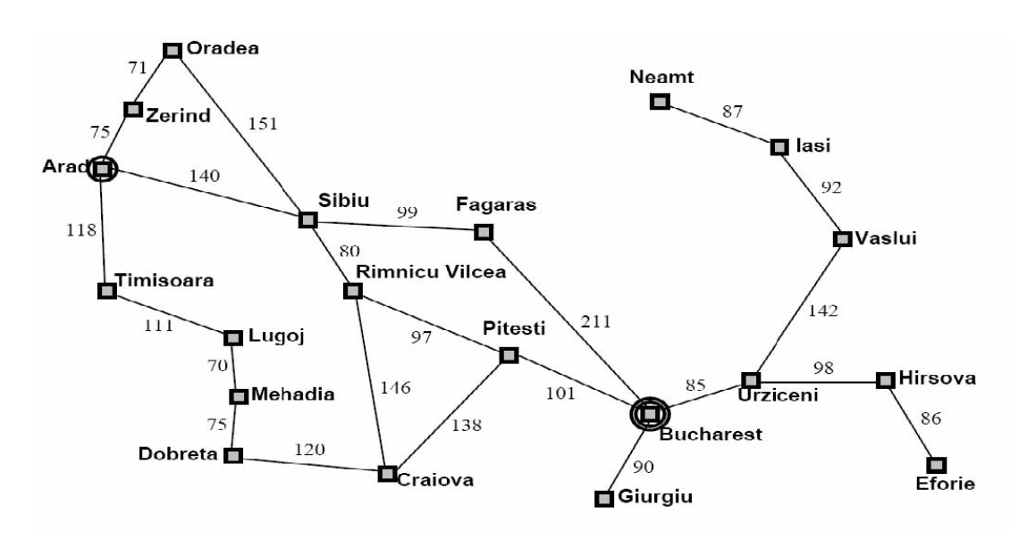

frontier

0. Arad 0

1. Zerind 75, Timisoara 118, Sibiu 140

2. Timisoara 118, Sibiu 140, Oradea 146

3. Sibiu 140, Oradea 146, Lugoj 229

4. Oradea 146, Rimnicu Vilcea 220, Lugoj 229, Fagaras 239

5. Rimnicu Vilcea 220, Lugoj 229, Fagaras 239, (Sibiu 297)

6. Lugoj 229, Fagaras 239, Pitesti 317, Craiova 366

7. Fagaras 239, Mehadia 299, Pitesti 317, Craiova 366

8. Mehadia 299, Pitesti 317, Craiova 366, Bucharest 450

9. Pitesti 317, Craiova 366, Dobreta 379, Bucharest 450

10. Craiova 366, Dobreta 379, Bucharest 418, Bucharest 450, Craiova 455

11. Dobreta 379, Bucharest 418, Bucharest 450, (Craiova 455), Dobreta 486, (Pitesti 504)

12. Bucharest 418, Bucharest 450, (Dobreta 486), (Craiova)

13. [terminal] Bucharest 418

